Phase 4 - Insurance Claim Fraud Detection

Problem Definition:

Identifying insurance fraud can be difficult because of the wide range of fraud patterns and low percentage of confirmed frauds in typical samples.   
  
The difficulty of identifying insurance fraud stems from the variety of fraudulent schemes and the low frequency of detected fraud instances in standard datasets. It's critical to weigh the costs of false alarms against the advantages of loss prevention while developing detection algorithms.

By improving prediction precision through machine learning techniques, loss prevention devices can achieve greater coverage with lower false positive rates. In order to detect fraud, this study investigates several machine learning techniques and evaluates their effectiveness using a variety of datasets. We investigate the effects of parameter optimization, feature engineering, and feature selection on predictive accuracy.

**Data Analysis :**

In order to begin tackling the difficult problem of insurance fraud detection, the program loads a dataset of insurance claims. This sets the foundation for thorough data analysis. The program explores the structure of the dataset, including the kinds of variables and their distributions, through exploratory data analysis (EDA). Important preprocessing procedures then follow, including the removal of unnecessary columns, the appropriate imputation of missing data, and the encoding of categorical variables to aid in modeling. To train and assess a Random Forest classifier model, the dataset is subsequently separated into training and testing sets, independent variables (features), and the target variable. Using a variety of evaluation criteria, including accuracy, precision, recall, and F1-score, the model's performance is carefully evaluated to provide insights into its effectiveness in

**EDA Concluding Remarks:**

Examining the dataset of insurance claims, we can see that we have a wide range of features that capture different parts of policy details, incident-related factors, and client information. We discovered missing values in a few columns during the investigation, such as "collision_type" and "police_report_available," which were appropriately handled using imputation techniques. Furthermore, we noticed a class imbalance in the target variable "fraud_reported," which suggests that there are less reported cases of fraud than claims that are not fraudulent. To provide fair forecasts, this imbalance must be carefully taken into account during model training. To help guide model building and uncover important predictors of fraudulent claims, additional study could investigate the significance of features. All things considered, the knowledge gathered from this exploratory research provides a strong basis for preprocessing and modeling, enabling us to create efficient fraud detection techniques to.

**Pre-processing Pipeline:** To prepare the dataset for model training and evaluation, the preprocessing pipeline in the application that is provided comprises of multiple steps:   
  
1. Eliminate Extraneous Columns:  
- To eliminate features that don't add anything to the prediction task, irrelevant columns like "policy_number," "policy_bind_date," and "_c39" are discarded using the `data.drop()` function.  
  
2. Address Incomplete Data:   
- In order to guarantee data completeness, missing values in categorical columns like "collision_type," "property_damage," and "police_report_available" are imputed with the most frequent value using `SimpleImputer(strategy='most_frequent')}.   
- To safeguard data integrity, missing values in numerical columns like "umbrella_limit," "capital-gains," and "capital-loss" are imputed using the median using `SimpleImputer(strategy='median')}.   
  
3. Categorical Variables to Encode:   
  
The binary categorical variables 'fraud_reported' are encoded using LabelEncoder() to translate categorical values into numerical representations through label encoding.  
When encoding categorical variables with more than two categories, pd.get_dummies() is used to construct binary columns for each category, eliminating the first category in order to prevent multicollinearity. This method is known as one-hot encoding.   
  
4. Divide the data into the target variable and features:   
  
Data is used to divide the dataset into independent variables (features) X and the target variable Y.'fraud_reported' for X and 'fraud_reported' for Y are the only columns that remain selected when using drop().

5. Divide the data into testing and training sets:  
  
To aid in the training and assessment of the model, the preprocessed data is further divided into training and testing sets using train test split().  
  
In order to create and assess the fraud detection model, these preparation processes guarantee that the dataset is appropriately cleaned, encoded, and divided into subsets. The application creates a strong and trustworthy predictive model by adhering to this pipeline, which efficiently prepares the data for later modeling stages.

**Explaining the Graphs:**

**Graph 1:** 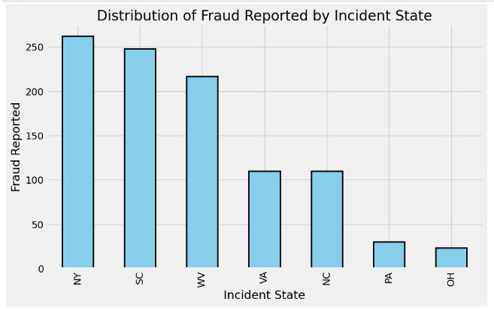

The above graph shows the distribution of reported fraud by event state in the form of a bar chart. The graph is explained as follows:

The many states in which the occurrences took place are represented by the **X-axis** (Incident State).   
The number of fraud reports for each event state is shown on the **Y-axis** (Fraud Reported).  
The **height of each bar** in the graphic denotes the number of fraud reports for that specific state, and each bar represents a distinct incident state.

All things considered, this graph gives viewers a rapid understanding of how reported fraud is distributed throughout distinct incident states and offers insightful information about possible patterns or trends regarding the incidence of insurance fraud in different states.

**GRAPH 2:** 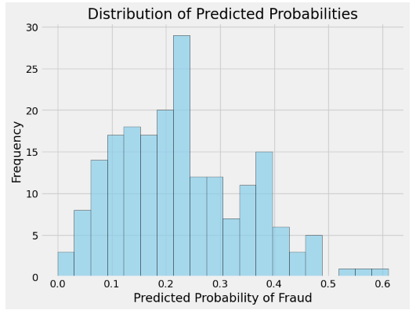

The provided graph is a histogram illustrating the distribution of predicted probabilities for the positive class (fraudulent) generated by a machine learning model, likely a Random Forest classifier (`rf_model`).

X-axis (Predicted Probability of Fraud): This axis represents the range of predicted probabilities for the positive class (fraudulent claims). Each bin on the x-axis corresponds to a specific range of predicted probabilities.

Y-axis (Frequency): This axis represents the frequency or count of occurrences for each range of predicted probabilities. It indicates how many instances fall within each bin on the x-axis.

Overall, this histogram allows us to visualize the distribution of predicted probabilities for fraudulent claims, providing insights into the model's confidence levels in predicting fraud. It helps assess the model's performance and may assist in setting decision thresholds for classification tasks.

**Graph 3:**

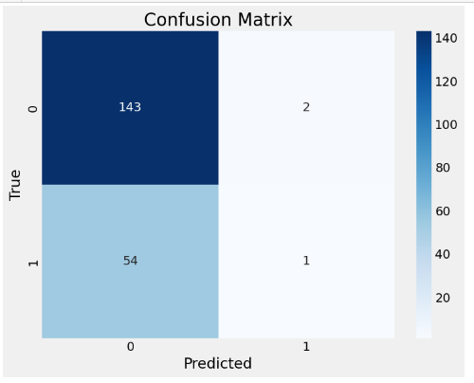

In the example given, True Positive (TP) is equal to 1, meaning that the model accurately identified one instance as fake.  
  
True Negative (TN): In the above example, TN = 143 shows that 143 of the occurrences were properly predicted by the model to not be fraudulent.   
  
False Positive (FP): The example given has FP = 2, meaning that the model mispredicted two occurrences as fraudulent when in fact they weren't.   
  
False Negative (FN): In the example given, FN = 54 means that 54 cases were genuinely fraudulent but the model mispredicted them as non-fraudulent.   
  
These words are essential for assessing a classification model's performance since they shed light on the model's capacity to accurately categorize examples into the appropriate classes and assist in determining how to strike a balance between sensitivity (the capacity to correctly identify positive instances) and specificity (the ability to correctly identify negative instances).

**Building Machine Learning Models:**

Building machine learning models involves the process of training algorithms on labeled data to learn patterns and relationships, which can then be used to make predictions or decisions on new, unseen data. Here's an overview of the steps involved in building machine learning models:

In the initial program provided, building machine learning models involves several key steps:

1. Data Loading: The program starts by loading the insurance claim dataset directly from a URL using the `pd.read_csv()` function from the Pandas library. This step ensures that the dataset is available for analysis and model training.

2. Data Exploration (EDA): Before building models, it's crucial to understand the structure and characteristics of the dataset. The program conducts exploratory data analysis (EDA) by viewing the first few rows of the dataset, checking data types, examining the number of unique values in each column, and exploring the distribution of certain categorical variables such as 'fraud_reported' and 'incident_state'.

3. Data Preprocessing: Preprocessing is a critical step to prepare the data for modeling. The program handles missing values in categorical and numerical columns, drops unnecessary columns, and encodes categorical variables using label encoding and one-hot encoding techniques. Additionally, the dataset is split into independent variables (features) and the target variable for model training.

4. Model Training: A Random Forest classifier model is chosen for training due to its effectiveness in handling classification tasks. The model is instantiated using `RandomForestClassifier()` from scikit-learn and trained on the training data using the `fit()` method.

5. Model Evaluation: After training the model, its performance is evaluated on the testing data. Key performance metrics such as accuracy, precision, recall, F1-score, and confusion matrix are computed using functions from scikit-learn (`accuracy_score()`, `classification_report()`, `confusion_matrix()`) to assess the model's ability to predict fraudulent insurance claims accurately.

6.Model Utilization: Once the model is trained and evaluated, it can be used to make predictions on new, unseen data. In the provided program, an example prediction is made on a single data point (`example_data`) from the testing set to demonstrate how the model can be utilized in practice.

Overall, building machine learning models in this program involves a systematic approach, starting from data loading and exploration, followed by preprocessing, model training, evaluation, and utilization. This process helps develop a predictive model for insurance claim fraud detection, providing valuable insights for insurance companies to mitigate fraud risks effectively.

**Concluding Remarks:**

When an insurance firm, agent, adjuster, or customer intentionally lies to get an unfair advantage, then insurance fraud occurs. It can happen when purchasing, utilizing, reselling, or underwriting insurance. Insurance fraud can be classified into various subcategories, including fraud committed by consumers and insurance firms. Fraud affects consumers and businesses financially, in addition to adding to insurance companies’ costs.

A more individualized and flexible approach is provided by machine learning, which enables you to flag questionable claims for additional inquiry and approve less questionable claims for quicker reimbursements. It enables claims teams, special investigation units, and other fraud specialists to act more quickly and with greater knowledge.

Compared to rules-based systems, machine learning fraud solutions have the potential to be more accurate, flexible, and easy to develop, which makes fraud analysis simpler and more efficient—especially when it comes to staying up to date with the newest frauds.